Movie Info Page Project

Submitted By: Ronit Anegundi , Krish   
Roll Number: 2462188 , 2462101  
College Email: [ronit.basavarajesh@btech.christuniversity.in](mailto:ronit.basavarajesh@btech.christuniversity.in),

[krish.h@btech.christuniversity.in](mailto:krish.h@btech.christuniversity.in)

Course: UI/UX Design Fundamentals  
Instructor Name: Ms. Nagaveena  
Institution: Christ University

Date of Submission: 13/08/2025

# Abstract

This project presents the design and development of a responsive movie information page for TimePass , aimed at providing users with detailed information about films, including synopsis, cast, trailers, and reviews, in an organized and visually appealing manner. The website features dedicated sections for different movie genres, top-rated films, and upcoming releases, each accompanied by high-quality posters, trailers, and concise descriptions to engage movie enthusiasts. Modern HTML5, CSS3, and responsive design techniques were implemented to ensure seamless compatibility across devices. The objective of this project is to create an elegant, user-friendly, and professional platform that enhances the movie browsing experience and promotes greater audience engagement.

# Objectives

• Develop a movie-themed single-page website that visually reflects the genre.

• Practice multimedia integration and CSS-based visual effects.

• Focus on organizing visual and textual content in an engaging manner.

# Scope of the Project

**Inclusions:**

* Header with website name and navigation links.
* Hero section featuring a featured movie poster and welcome message.
* Movie sections with categories such as Latest Releases, Top Rated, and Upcoming Movies.
* Detailed movie info pages including synopsis, cast, trailers, and ratings.
* About Us section with information about the website or platform.
* Contact section with icons for email, social media, and feedback form.
* Footer with social media links and newsletter subscription placeholder.

**Exclusions:**

* No backend or server-side database integration.
* No advanced JavaScript animations, filtering, or lightbox features.

**Target Devices:**

* Desktop, tablet, and mobile.

# Tools & Technologies Used

|  |  |
| --- | --- |
| Tool/Technology | Purpose |
| HTML5 | Semantic markup for content structure |
| CSS3 | Styling, layout, responsiveness, hover effects |
| VS Code | Code editor for development |
| Chrome DevTools | Testing and debugging |
| Font Awesome | Scalable icons for contact info and social media |
| Unsplash/Pexels | Free high-quality images |

# HTML Structure Overview

The HTML structure uses semantic tags like <header>, <nav>, <section>, and <footer>. Menu items are arranged inside <div> containers with images and descriptions.

# CSS Styling Strategy

The styling uses an external stylesheet (style.css) and applies a warm color palette. Flexbox is used for alignment, Grid for menu layout, and hover effects for menu items. Media queries are used for responsiveness.

# Key Features

- Warm color theme matching restaurant ambiance.  
- Responsive design using Flexbox and Grid.  
- Hover zoom effects on menu items.  
- Contact section with icons.  
- Footer with social media links and newsletter form placeholder.

# Challenges Faced & Solutions

1. Text readability on hero image → Added semi-transparent overlay.  
2. Even spacing of menu cards → Used CSS Grid with gap property.  
3. Image distortion on resize → Used object-fit: cover.

# Outcome

The final design is clean, functional, and adaptable for any OTT platform. This project improved my HTML/CSS skills and knowledge of UI/UX principles.

# Future Enhancements

- Add JavaScript for interactivity.  
- Backend integration for contact and newsletter forms.  
- CSS animations for smooth transitions.  
- Dark mode toggle.

# Sample Code

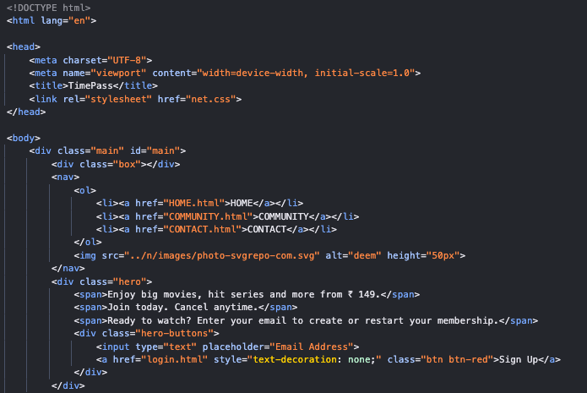

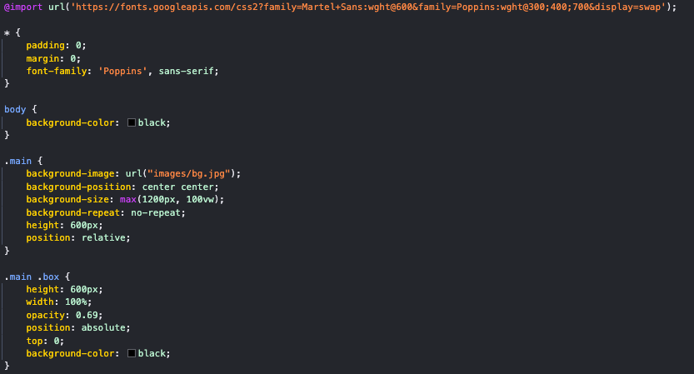

# Screenshot of Final Output

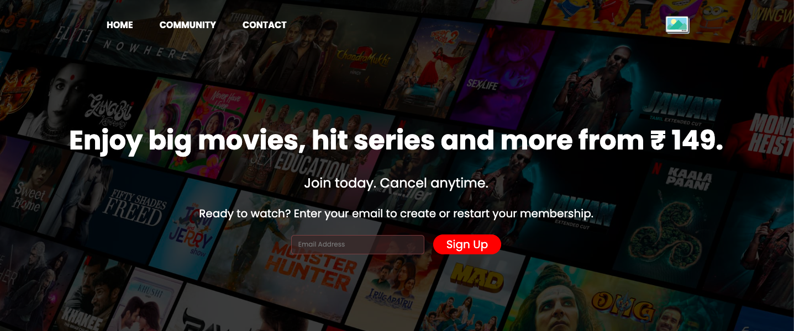

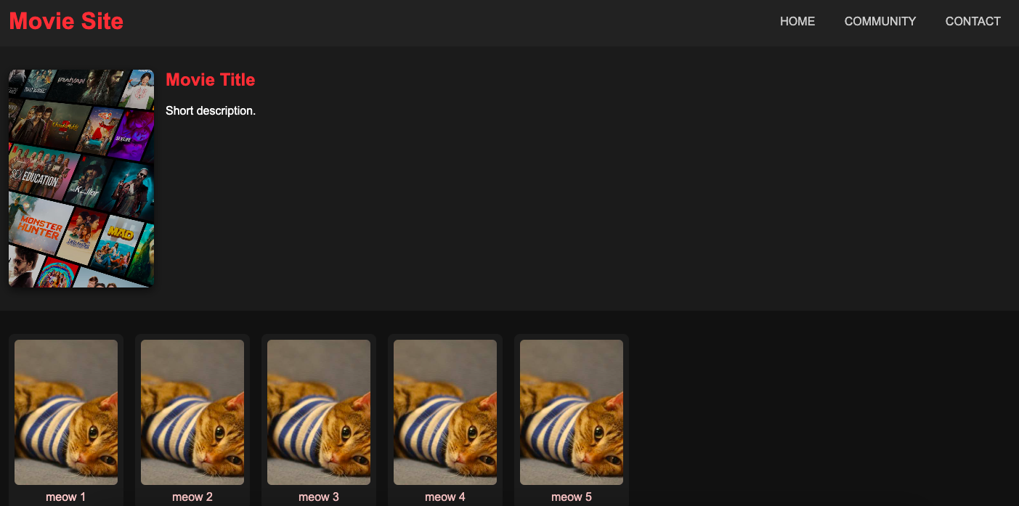

# Conclusion

The Movie Info Page project demonstrated the importance of aligning design with brand identity. It served as a practical exercise in HTML5 and CSS3, focusing on responsive design, layout composition, and user engagement through visual elements.

# References

- L&T LMS: https://learn.lntedutech.com  
- Font Awesome: https://fontawesome.com  
- Unsplash: https://unsplash.com  
- W3Schools: https://www.w3schools.com